**FUNCTIONAL SPECIFICATIONS**

**Venn Diagram Application**

**Group 12**

**02/23/2020**

**Version 1.2.0**

**1 INTRODUCTION** 3

1.1 Purpose 3

1.2 Intended Audience 3

1.3 Intended Use 3

**2 REQUIREMENTS** 3

2.1 Users 3

2.2 Overview of Functional Requirements 3

2.3 Overview of Technical Requirements 4

**3 CASES** 4

3.1 Use Cases 4

3.2 Acceptance Test Cases 4

**4 VERSION HISTORY** 7

# INTRODUCTION

A Venn Diagram is “a diagram representing mathematical or logic sets pictorially as circles or closed curves within an enclosing rectangle (the universal set), common elements of the sets being represented by the areas of overlap among the circles” (Dictionary.com, n.d.).

## Purpose

## The purpose of this project is to provide users with an interactive Venn diagram that maximizes customizability to the user’s desire to view and see the relationship between sets of information/items.

## Intended Audience

Users of this product may vary from a pre-teen to an older adult.

## Intended Use

An application that can draw customizable Venn diagrams for Strings of information.

**2 REQUIREMENTS**

## 2.1 Users

Product is designed for primary users, but can also be used by secondary users.

*Primary Users*

* Ranging from teens to middle-aged adults

*Secondary Users*

* Pre-teens and the elderly

## 2.2 Overview of Functional Requirements

* User is able to type anywhere they click in the Venn diagram under the subtitles besides the outside of the Venn diagram
* Text can only be placed inside the boundaries of the shape
* A text area should be added to the respective side or middle of the Venn diagram when clicking inside the boundaries of the particular area
* A string of information that is longer than 22 characters should be scaled to the next line

## 2.3 Overview of Technical Requirements

* Venn diagram should consist of 2 overlapping circles
* Design of Venn Diagram is customizable (Colour, Theme, etc.)

**3 CASES**

## 3.1 Use Cases

* Organise information visually
* Compare and contrast two or more sets, choices, languages, products or services, etc.
* Statistics and Probability to predict the likelihood of certain occurrences
* Used as a tool to teach

## 3.2 Acceptance Test Cases

* If the user clicks the top title of the Venn diagram where it says ‘Insert Title’ and types ‘A v B’, and the user clicks the sub-title where it says ‘Insert Title’ at the top of the left circle and types ‘A’ and the user clicks the sub-title where it says ‘Insert Title’ at the top of the right circle and types ‘B’ the Venn diagram should like this:

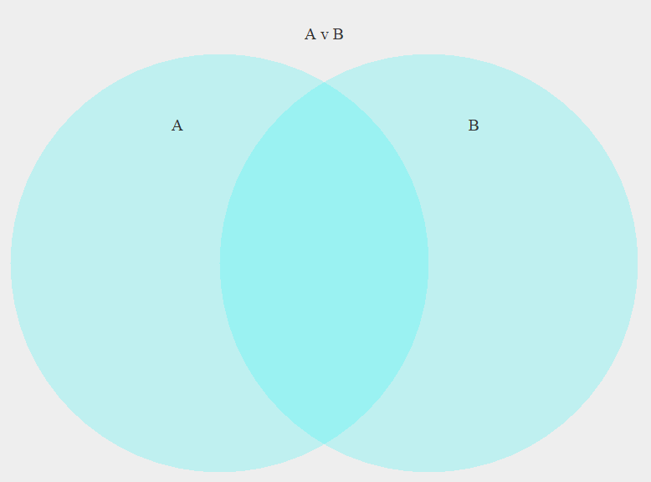

* 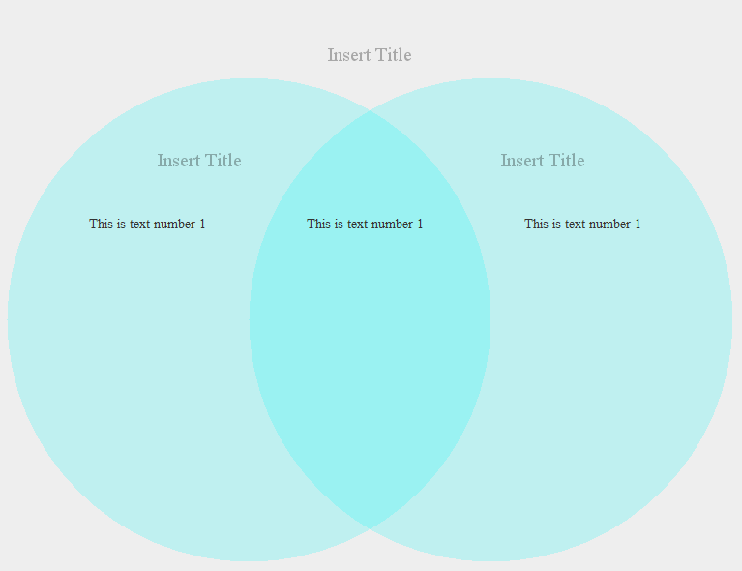If the user clicks below the subtitle on the right side of the Venn diagram, then a text should appear ‘-This is text number 1’, then if the user clicks the middle of the Venn diagram a text should appear in the middle section ‘-This is text number 1’, then if the user clicks the left side of the Venn diagram a text ‘-This is text number 1’ should appear and the Venn diagram should look like this:

* If the user clicks below the subtitle on the left side of the Venn diagram, then a text should appear ‘-This is text number 1’ and if the user highlights the text to erase it and types ‘Testing scaling texts functionality right now’, and click enter, then Venn diagram should look like:

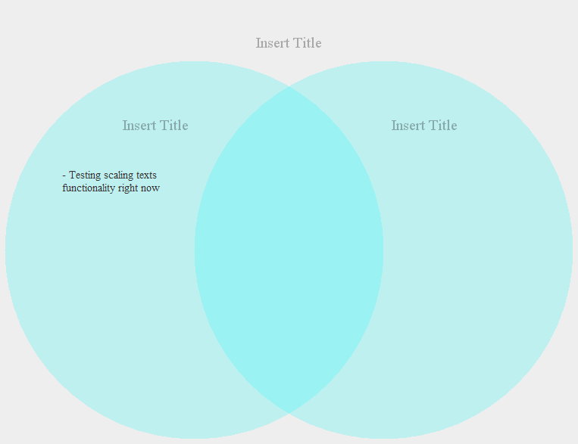

* If the user clicks the middle of the Venn diagram and types, after deleting ‘This is text number 1’:

“His palms are sweaty, knees weak, arms are heavy. There's vomit on his sweater already, mom's spaghetti. He's nervous, but on the surface, he looks calm and ready. To drop bombs, but he keeps on forgettin. What he wrote down, the whole crowd goes so loud. He opens his mouth, but the words won't come out. He's chokin' how, everybody's jokin' now. The clocks runs out, time's up, over. Blow” (Eminem, 2002)!

After clicking enter, the following 328 characters should be displayed,

”His palms are sweaty, knees weak, arms are heavy. There's vomit on his sweater already, mom's spaghetti. He's nervous, but on the surface, he looks calm and ready. To drop bombs, but he keeps on forgettin. What he wrote down, the whole crowd goes so loud. He opens his mouth, but the words won't come out. He's chokin' how, everybody's jokin' now” (Eminem, 2002).

due to the 328-character limit per object. And the Venn diagram should look like this:

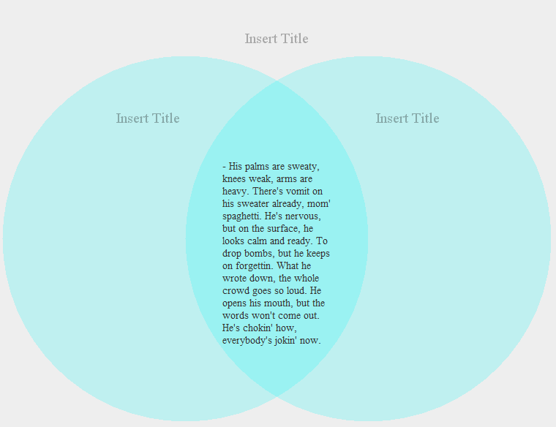

* If the user clicks outside the boundary of the Venn diagram, then the user should not be able to type anything

**4 VERSION HISTORY**

| VERSION | REVISION DATE | DESCRIPTION OF CHANGE | AUTHOR |
| --- | --- | --- | --- |
| 1.0.0 | Jan 26 2020 | 1st Version of Product | Group 12 |
| 1.1.0 | Feb 9 2020 | 1st Version of Prototype | Group 12 |
| 1.2.0 | Feb 23 2020 | 2nd Version of Prototype | Group 12 |
|  |  |  |  |
|  |  |  |  |
|  |  |  |  |
|  |  |  |  |